USER

MANUAL

CHUSKY

Designed by:Sergio

1. Introduction of the project:

This is my second project named chusky, it’s an obstacle avoiding and a Bluetooth robot, you can select what you want.

I design all the structure, you can download the files if you want to replicate the robot, all the structure can be made in a 3D printer.

It’s an 2WD robot with a pushpin in the front , it can go in 8 directions. You can see all the materials you need in the B.O.M of the project.

1. Electric scheme:

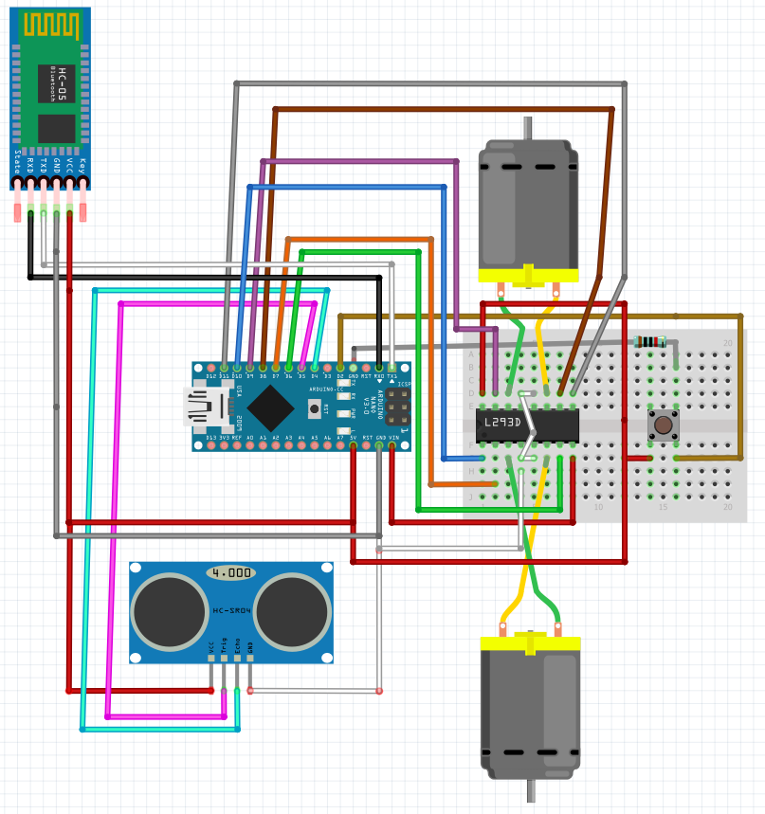

1. Assembly description:

----All the components ---

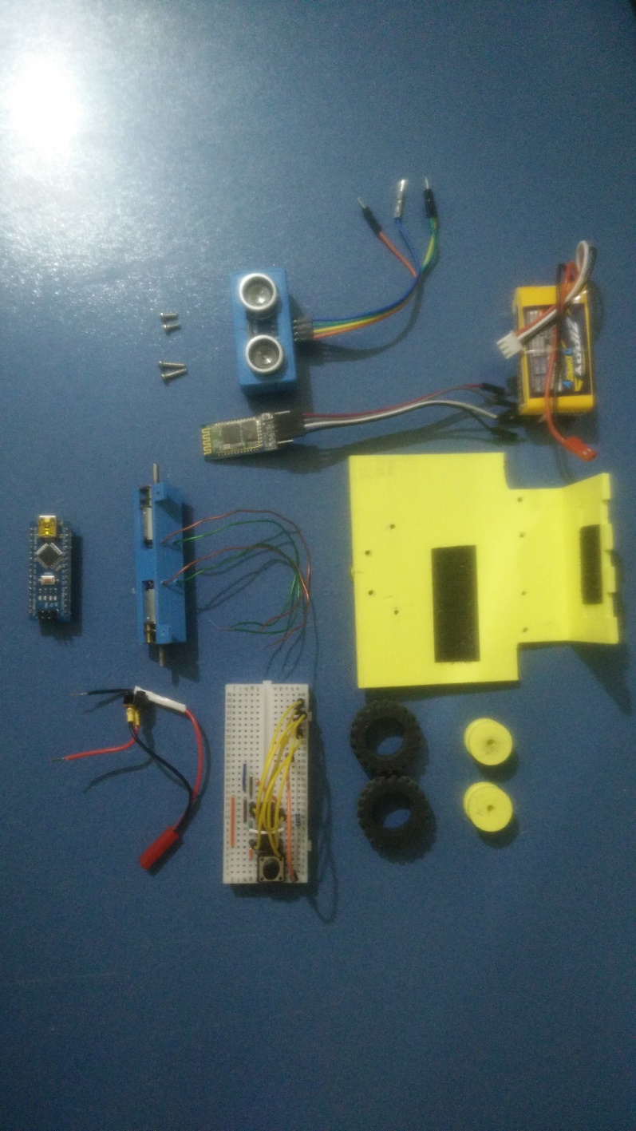

1-First of all you have to paste the “Base and back” with the “Pushpin supp” using super glue. Then put the pushpin in the “Pushpin supp”.  
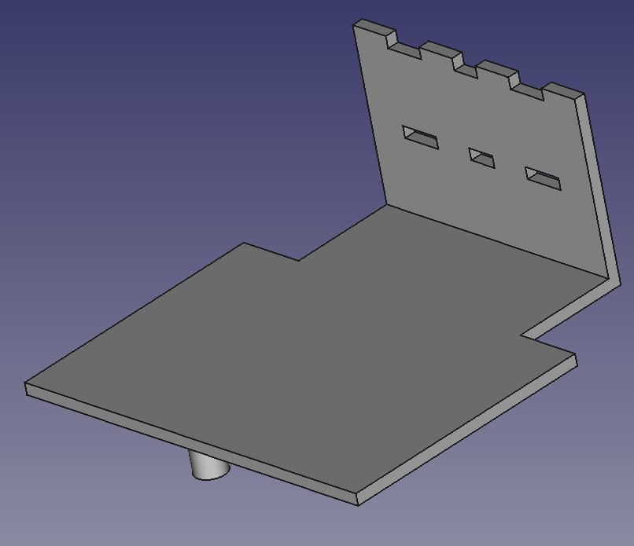

You will have something like that

2- Mount the motors in the “Motor bracket”, you have to do 4 holes in the bracket for the wires of the motors.

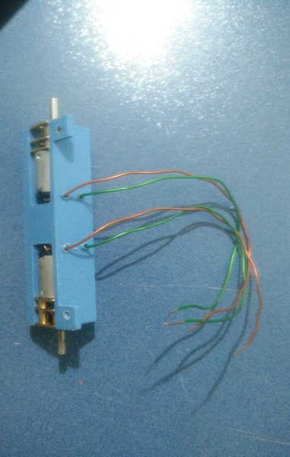

3- Then put the “Tire Wheel” on the “Pololu Wheel”, and all of it in the motors.

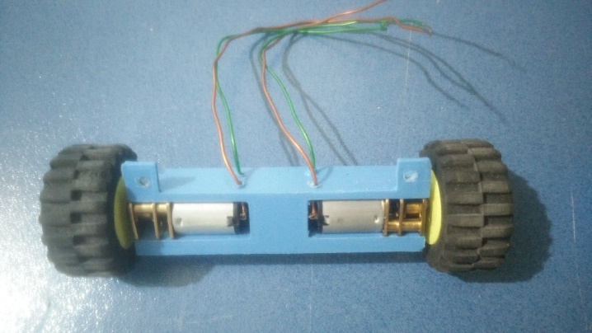

4-Continue putting the “Motor bracket” with all the pieces in the “base and back”. Use 2 of the screws.

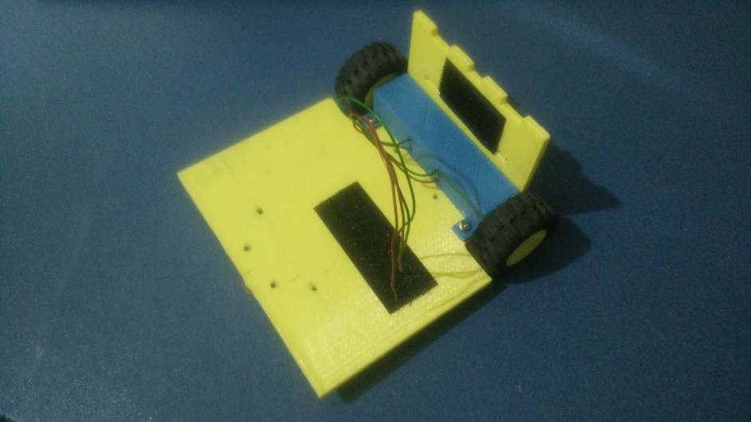

5-The next step is making all the cabling, use the electric scheme and make the same connections.

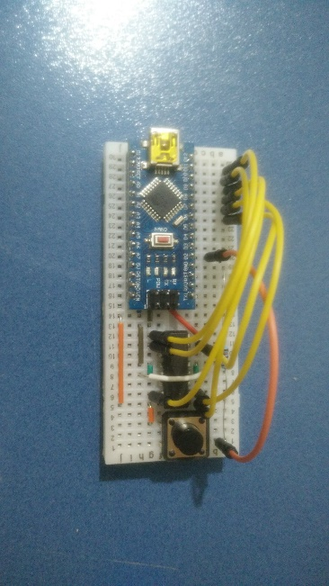

Use the “adhesive Velcro” to link the Arduino to the base.

6-Take the hc-sr04 and put it in between the “Sonar case” and the “Sonar plate”, and use super glue to stick it like that.

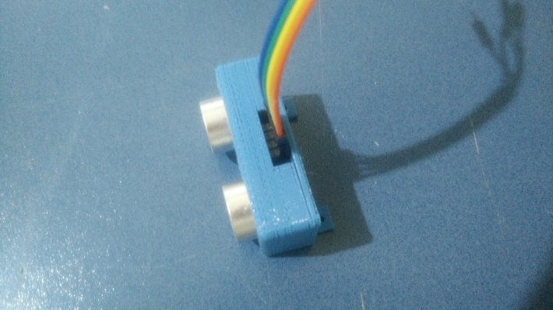

7-Mount it on the “Base and back” with the 2 screws remaining and add too the Bluetooth.

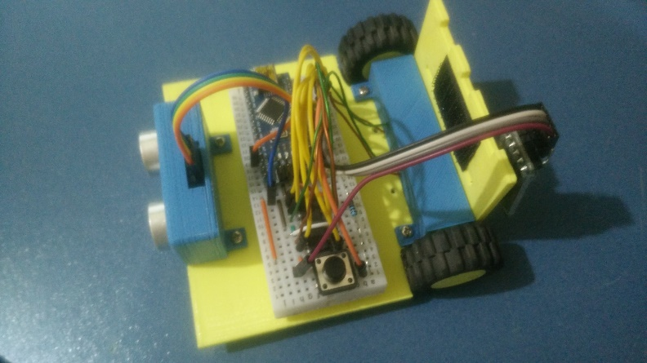

8-The last step is making the supply wires with interrupter for ON/OFF the robot. Then connect the Lipo with the wires on the Arduino.

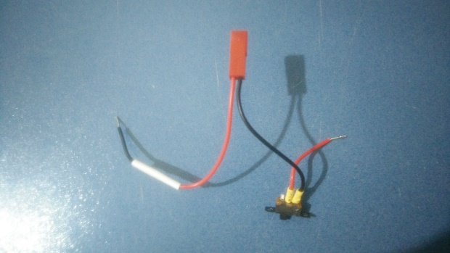



THE RESULT!!



4. Firmware description:

This is a robot how have 2 modes of motion, you can select it with the button of the proto.

To do this change I use an interruption in the code, this interrupt, change the value of the bollean variable ( at the start, the robot is in the 2 mode, how is the opci = 1) .

When you press the button, the mode changes to obstacle avoiding (making opci=0).

Both opci are evaluated in a switch, where opci = 1 and opci= 0 are 2 cases.

---- IN OBSTACLE AVOIDING ----

The robot will ride forward until the hc sr04 detect the obstacle, if the obstacles are lower than 25cm , the robot turn right and continue riding forward so on.

---- IN BLUETOOTH MODE ----

The robot will stay stop, until you press any of the keys, then , the robot read that order, and run the part of the code associate with the key.